Statistics for Data Science

YU lisha 俞丽莎

Email: [lishayu@ln.edu.hk](mailto:lishayu@ln.edu.hk)

Phone: 26168737

# General

meet her at office time at Wong Administration Building

Office Hour:

Tuesday 11:00 am - 12:30 pm 14:00 pm - 15:00 pm

Thursday 15:30 pm - 16:00 pm

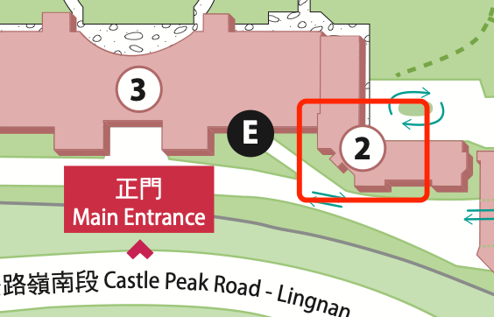

## Assessment

attendance and participation 10%

Assignments 40%

Examination 50%

GAI is NOT permitted in assignment, case study and examination in this course.

## Required/Essential Readings

I think better to practice other than read of this course

目录

第1章 General - 1 -

1.1 Assessment - 1 -

1.2 Required/Essential Readings - 1 -

第2章 Week 1 Lecture 1 - 3 -

2.1 Tentative Schedule - 3 -

第3章 Week 2 Lecture 2 - 4 -

3.1 What is computation in programming - 4 -

第4章 Week 3 Lecture 3 - 5 -

4.1 Software Development Process - 5 -

4.2 Python Data Types - 5 -

第5章 Week 4 Lecture 4 - 6 -

5.1 OOP: Object Oriented Programming - 6 -

第6章 Week 5 Lecture 5 - 7 -

6.1 File Processing - 7 -

第7章 Week 6 Lecture 6 - 8 -

7.1 Lists vs String - 8 -

第8章 Week 7 Lecture 7 - 9 -

8.1 Mann-Whitney U-Test - 9 -

# Week 1 Lecture 1

## Tentative Schedule

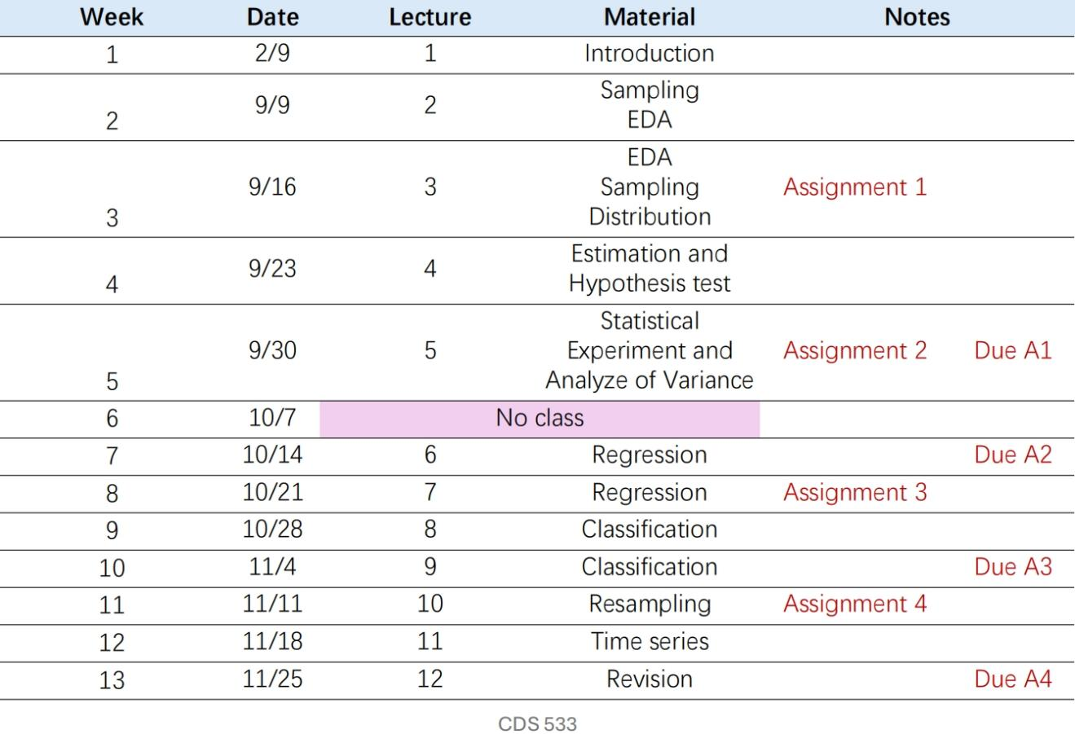

# Week 2 Lecture 2

## What is computation in programming

writing functions to dealing inputs to generate outputs

# Week 3 Lecture 3

## Software Development Process

## Python Data Types

Getting the Data Type

print(type(x))

# Week 4 Lecture 4

## OOP: Object Oriented Programming

variables are classified and managed in object with fields and functions inside

# Week 5 Lecture 5

## File Processing

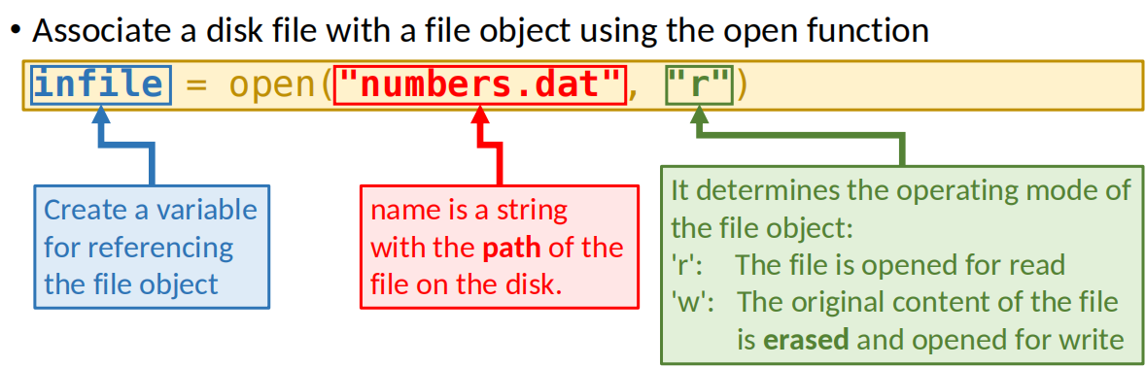

# Week 6 Lecture 6

## Lists vs String

A list is very similar to a string. In fact, string is a special version of list.

Lists are mutable, meaning they can be changed. Strings cannot be

changed.

counts[w] = counts[w] + 1

# Week 7 Lecture 7

## Mann-Whitney U-Test

The Mann-Whitney U-Test is non-parametric counterpart to the t-test for

independent samples.